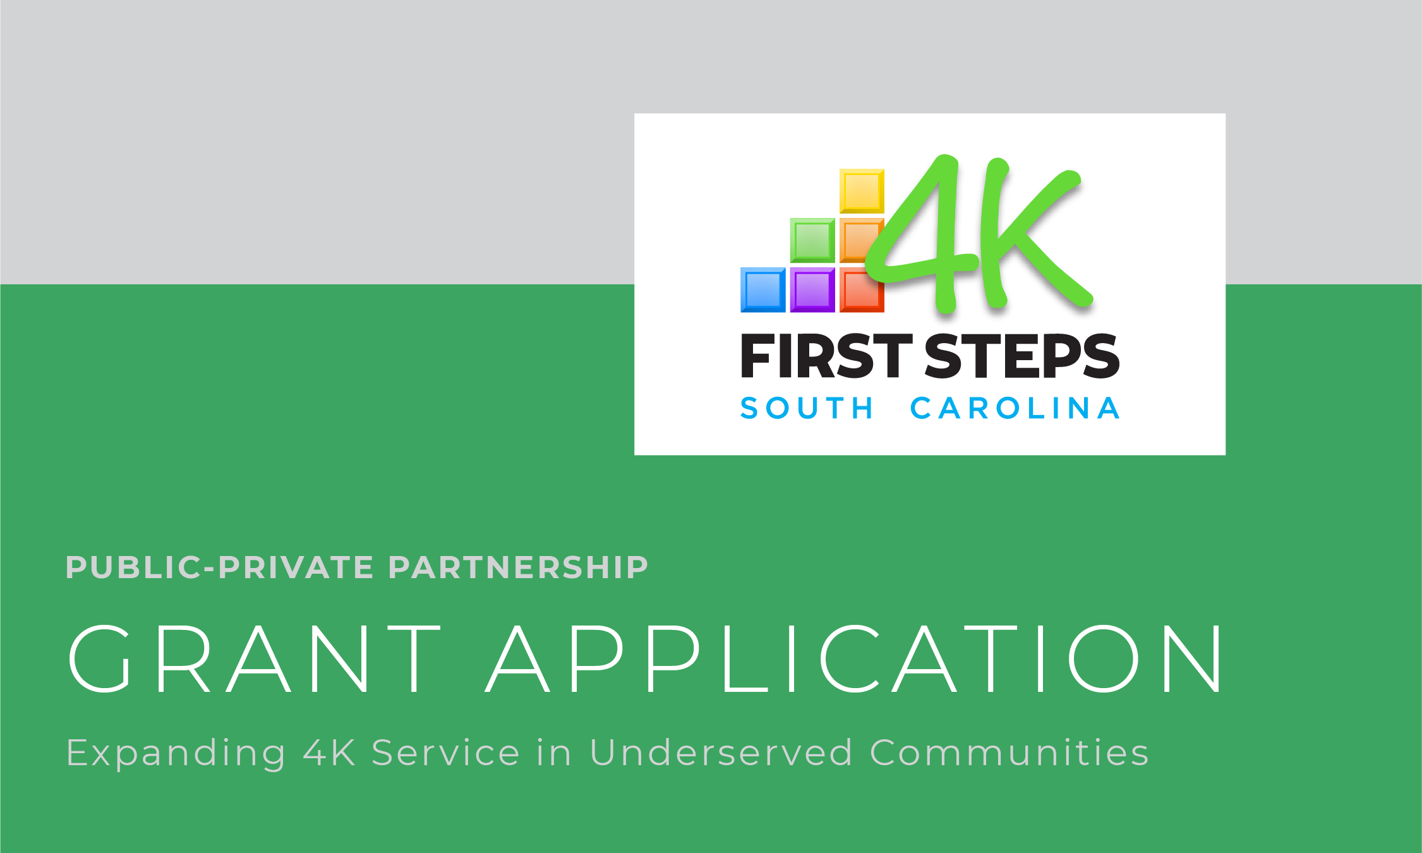

Renovation or Refurbishment of Existing Public Structures to Serve Four-Year-Old Children from Multiple Counties and Multiple School Districts

Proviso 1.76 of the General Appropriations Act for FY20 charges South Carolina First Steps with the development of a pilot program using funds appropriated for the Child Early Reading and Development Education Program (CERDEP) to provide CERDEP services in underserved communities serving multiple counties and multiple districts. For this pilot, First Steps is authorized to grant up to $1,000,000 in grants to public-private partnerships to address building renovations and designs necessary to get the publicly-owned building and its classrooms into compliance with licensing regulations and other obstacles that prevent participation in the CERDEP program following guidelines developed by SC First Steps.

ELIGIBILITY CRITERIA

All applicants must meet the following eligibility criteria in order to be considered for funding:

- The applicant must demonstrate the extent to which the public facility for which renovation funds are being requested, the proposed operator of CERDEP services, and any other relevant project partners collectively constitute a public-private partnership.
- The applicant must name a public or private entity that will be responsible for operating the 4K center, including establishing or maintaining a child care license in good standing with the SC Department of Social Services, that meets the qualifications to be a private CERDEP (First Steps 4K) provider, and abiding by all requirements of the private CERDEP (First Steps 4K) program as required by SC First Steps.
CERDEP Guidelines and Tuition Rates for 2019-20:

- https://scfirststeps.org/wp-content/uploads/2019/09/First-Steps-4K-Guidelines-2019-2020-8.2.19-FINAL.pdf.
- Note CERDEP guidelines and tuition rates are subject to change on an annual basis.

To learn about child care licensing regulations:

- https://www.scchildcare.org/providers/become-licensed.aspx
- The applicant must describe how the 4K center will recruit and serve at least 10 four-year-old children annually residing in multiple counties and multiple school districts, including at least one school district that is eligible to participate in the CERDEP program for the 2019-20 school year. CERDEP-eligible school districts for 2019-20 include: Abbeville, Aiken, Allendale, Anderson 2, Anderson 3, Anderson 5, Bamberg 1, Bamberg 2, Barnwell 19, Barnwell 29, Barnwell 45, Berkeley, Calhoun, Cherokee, Chester, Chesterfield, Clarendon 1, Clarendon 2, Clarendon 3, Colleton, Darlington, Dillon 3, Dillon 4, Dorchester 4, Edgefield, Fairfield, Florence 1, Florence 2, Florence 3, Florence 4, Florence 5, Georgetown, Greenwood 50, Greenwood 51, Greenwood 52, Hampton 1, Hampton 2, Horry, Jasper, Kershaw, Laurens 55, Laurens 56, Lee, Lexington 2, Lexington 3, Lexington 4, Marion, Marlboro, McCormick, Newberry, Oconee, Orangeburg, Richland 1, Saluda, Spartanburg 3, Spartanburg 4, Spartanburg 6, Spartanburg 7, Sumter, Union, Williamsburg and York 1.
- SC First Steps intends to award funding to multiple underserved communities. The applicant must demonstrate the availability of additional public, private, or in-kind resources needed to complete all necessary renovations as required by child care licensing and the CERDEP program and begin operations within a reasonable timeframe, to be agreed upon by the applicant and SC First Steps.
- Providers participating in this pilot are required to participate in the CERDEP program and provide high-quality, center-based programs as defined herein for a minimum of three years, and successful applicants will demonstrate a longer term commitment (min. 10 years recommended). Failure to participate for three years may require the provider to return a portion of the supplemental allocation at a level determined by the Office of First Steps to School Readiness.

APPLICATION REVIEW CRITERIA

All applicants meeting the above eligibility criteria will be considered for funding based on the following priorities:
- The extent to which the applicant demonstrates the existence of a public-private partnership that will, to the extent possible, provide assurance that the investment of public funding requested by the applicant for this pilot project will result in a long-term, secure public benefit in the form of CERDEP services provided at the capacity level stated in the applicant’s funding request.
- The need for four-year-old kindergarten services within the targeted underserved communities.
- The number of classrooms to be created/expanded by this project.
- The investment of pilot program funds on a per child basis.
- The quality of the applicant’s long-term operations and recruitment plan, including the ability to provide the additional financial and other resources needed to complete renovations and support ongoing operating costs. Preference will be provided to applicants that can demonstrate a sustainable operations plan for at least a 10-year period.
- Geographic distribution of funded projects.
Costs eligible/not eligible for pilot grant funding:

Actual funding awarded will be based on an evaluation of allowable costs on a per project basis, as determined by SC First Steps. Allowable costs include building renovations and upfitting necessary to operate a high-quality, center-based CERDEP program, including: making the facility compliant with DSS licensing regulations and CERDEP guidelines; kitchen or food service needs; transportation barriers; and classroom or outdoor/playground equipment needs. Ineligible costs include, but are not limited to:
- Lead or asbestos abatement
- Purchase of land or facilities
- Costs not related to renovations needed to operate a CERDEP (First Steps 4K) program
- Classroom materials and supplies (new CERDEP classrooms are eligible for up to $10,000 in startup funding for this purpose)
- Ongoing operating costs

AWARD PROCESS

Prospective applicants are encouraged to contact SC First Steps to discuss their project, prior to submitting an application.Please direct questions regarding this pilot funding opportunity to Martha Strickland, First Steps 4K Director, at 803-734-0247 or mstrickland@scfirststeps.org.

Applications that meet the minimum eligibility criteria will receive a site visit from SC First Steps and potentially other partners (SCDSS, etc.) to ensure the site renovation plan is feasible and cost effective and can meet all requirements for child care licensing and the CERDEP 4K program.

Applications received by February 14, 2020 will be considered for initial funding, with an expected funding decision by April 1, 2020. Subsequent applications received after February 14, 2020 will considered on a rolling basis until pilot funding is exhausted. All pilot grants must be awarded and funds obligated by June 30, 2020.

For each funded application, a project timeline and disbursement schedule will be created between the applicant organization and SC First Steps. Generally, funds will be disbursed based on percentage of completion schedule, to be determined on a per project basis. Note building renovations will require a bid submitted by a licensed and bonded contractor. Renovations require architectural plans to be submitted to DSS and the Fire Marshal prior to any renovations being started. First Steps will work with grantees to document and ensure that funds are used only for approved items.
Once renovations are nearing completion, the organization committing to operating the site’s CERDEP program must apply and be accepted as a First Steps 4K provider. Application information is available at https://scfirststeps.org/get-involved/become-a-first-steps-4k-provider/.

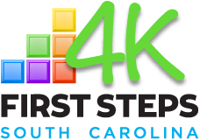

Expanding 4K in Underserved Communities through Public/Private Partnerships:
Renovation or Refurbishment of Existing Structures to Serve Four-Year-Old Children
from Multiple Counties and Multiple School Districts

APPLICATION FORM

Submit an electronic copy of this application, signed and scanned as a pdf, along with electronic copies of all attachments to mstrickland@scfirststeps.org.

Priority deadline: February 14, 2020 by 5:00 p.m.
Please submit one application per facility for which renovation funding is being requested.

APPLICANT INFORMATION

Name and Mailing Address of Applicant Organization: | Primary Contact Person for this Application:
Contact Person’s Phone Number: | Contact Person’s Email:
Describe how the applicant represents a public-private partnership, in terms of: a) ownership of the facility; b) proposed operator of CERDEP services; and c) other funding sources or collaborative partners. Describe the extent to which the applicant can provide assurance that the renovated facility will provide CERDEP services at or above the capacity level specified in this application, in perpetuity (assuming the availability of state 4K funding at or above the current level).

FACILITY INFORMATION

Name and Physical Address of Facility: | County and School District Where Facility is Located:
Name and Contact Information of Facility Owner, if Different from Applicant: | Facility Owner is:  __ state government  __ county government  __ local government (specify):  __ special purpose district (specify):  __ public college or university  __ other public or private entity (specify):
Briefly describe the facility in its current condition (building construction, square footage, former uses, current occupancy or if vacant, for how long):

PROPOSED FACILITY RENOVATION

# of CERDEP 4K classrooms to be created:  # of CERDEP 4K students to be served, per classroom: |  | Describe other classrooms, programs or services to be housed at this location:
Renovation Plan:
Please describe, in detail, the barriers currently preventing your participation in the First Steps 4K program and how addressing them with grant funding will enable the expansion of service to ten or more children annually. (These barriers might include building renovations necessary to make your space compliant with DSS licensing regulations, kitchen or food service needs, transportation barriers, and classroom or outdoor/playground equipment needs.)

Along with each need, please document the cost associated. Use as much space as is needed, attaching estimates and/or documenting vendor prices as possible. Attach a proposed budget breakdown for the renovation plan as well as vendor quotes and architectural/technical drawings, if available.

Describe any other public, private, or in-kind resources that will be utilized to accomplish the needed renovations, and the amount of those resources.

Total Grant Funding Requested:  $ | Total Matching Funds:  $ |  |  |  | Total Project Cost:  $
DESCRIPTION OF UNDERSERVED COMMUNITIES

Which counties will your CERDEP 4K program serve? |  |  |  | Which school districts will your CERDEP program serve?
Describe the need for 4K services within the targeted communities. Include as justification the estimated number of low income four-year-olds within the target communities and the availability (or lack of) publicly funded four-year-old kindergarten programs.

OPERATIONS/SUSTAINABILITY PLAN

Name and Mailing Address of Organization that will Operate the Private CERDEP Program and hold the Facility’s Child Care License: |  |  | FEIN #:
 |  |  | If current licensee, child care license #:
Type of Provider:  __ private non-profit  __ private for profit  __ private faith-based  __ public entity (specify): |  |  | Name of Center Owner or Director:
Center Owner/Director Phone: |  |  | Center Owner/Director Email:
Describe the organization’s history and experience with operating quality early learning programs, including preschool programs, including levels achieved within ABC Quality and/or other accreditations.

Describe the timeline for completing renovations, recruiting staff, and opening classrooms:

How will your program recruit the number of children needed to sustain the program?

Attach a proposed three-year annual operating budget (revenue and expenses) for the proposed center. Include the estimated tuition revenue from First Steps 4K as well as the amount and sources of other revenue or funding needed. First Steps 4K tuition and transportation reimbursement amounts for 2019-20 can be found at https://scfirststeps.org/get-involved/become-a-first-steps-4k-provider/.

Indicate what Attachments are included with this application:

- Proof of ownership of the facility and property (required)
- Renovation Plan budget breakdown (required)
- Letter of commitment/contract/MOU with the facility owner and the proposed center operator, if different from the applicant organization (required)

- Proposed three-year operating budget (required)

- Scope(s) of work and cost estimates from proposed vendor(s), if available
- Architectural or technical drawings of the current and/or proposed facility, if available
- Letters of commitment from funders and project partners, if applicable

- Other (specify):

I acknowledge that:

- As a recipient of grant funds, it is my intent to become an approved First Steps 4K provider – serving a minimum of 10 eligible children annually - and to adhere to all requirements established for participating providers. I recognize that this entails provision of a high-quality, center-based program - including use of a state approved curricula and documentation of assessment through Gold® by Teaching Strategies.
- By receiving grant funds, I am agreeing to participate in the First Steps 4K program for at least 3 years.
- Failure to participate for three years may require the provider to return the materials purchased and/or a portion of the grant funded expended at a level determined by SC First Steps to School Readiness.

On behalf of Applicant Organization:

__________________________ ______________________________ _________________
Signature Name/Title Date

On behalf of the Facility Owner:

__________________________ ______________________________ _________________
Signature Name/Title Date

On behalf of the Center Operator:

__________________________ ______________________________ _________________
Signature Name/Title Date

