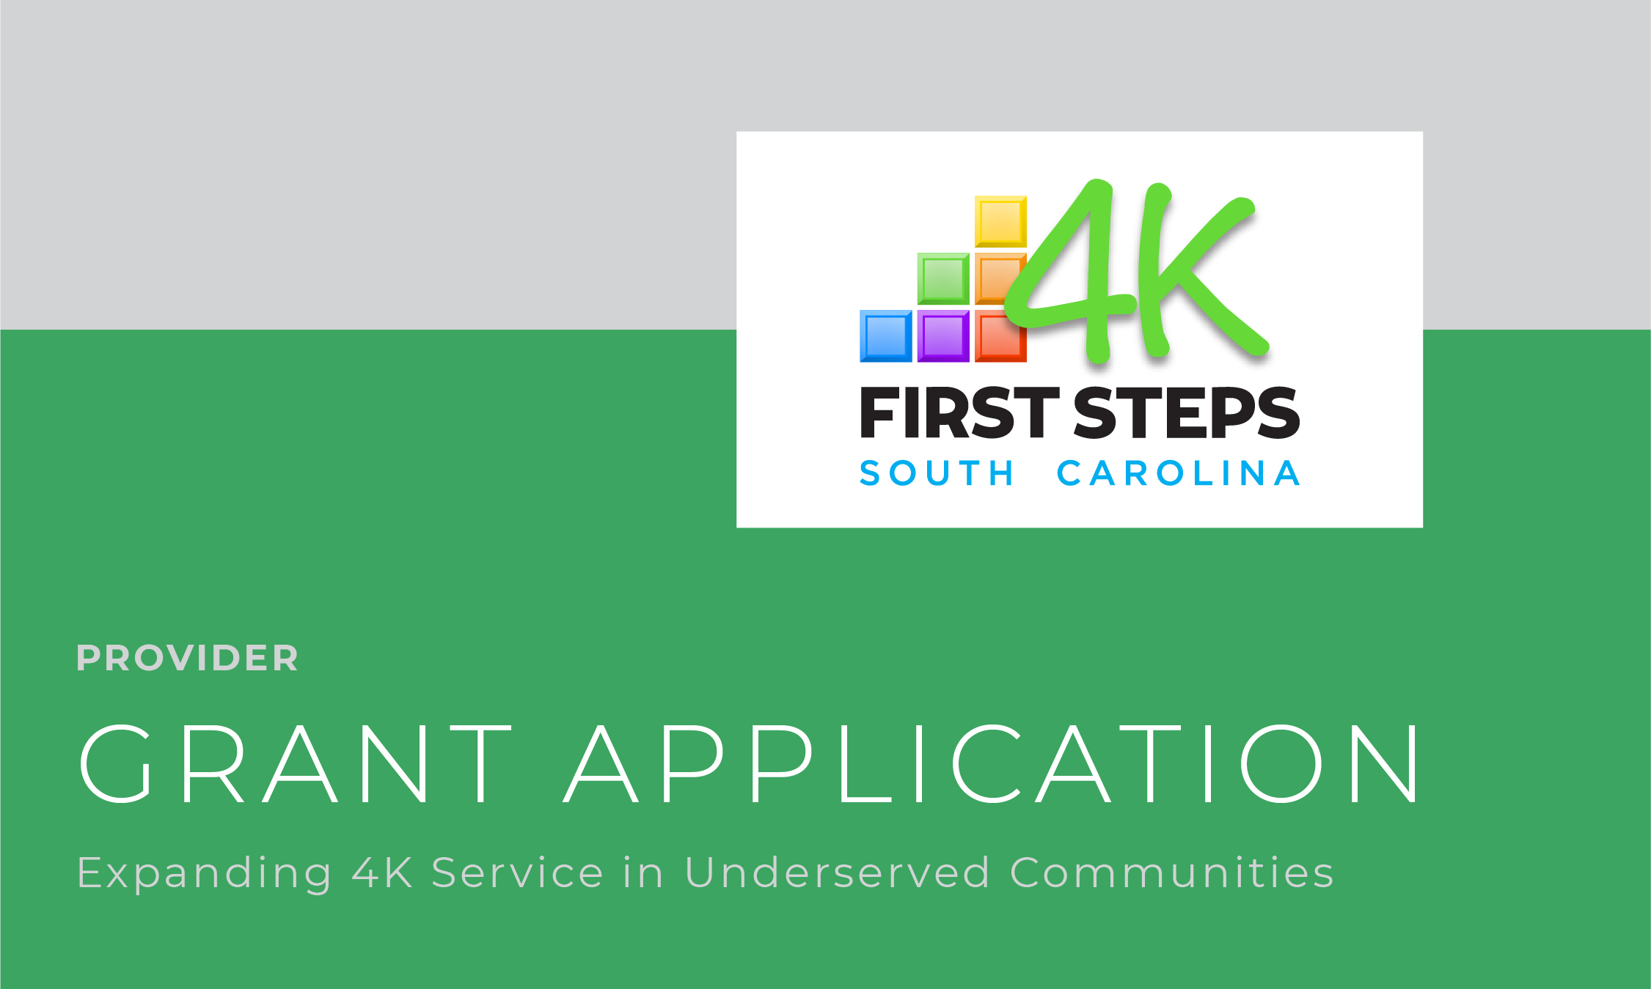

Proviso 1.76 of the General Appropriations Act for FY20 charges First Steps with the development of a pilot program through which grant funds of no more than $30,000 may be awarded to newly created and/or newly approved 4K providers in underserved SC communities for the purpose of expanding access to service. These one-time funds are intended to support providers in overcoming obstacles currently preventing their participation in the 4K program. Such needs may include, but are not limited to, building renovations documented as necessary to bring proposed classrooms into compliance with licensing regulations, materials/equipment and staffing costs.
Providers receiving this one-time supplement are expected to participate in the program and provide high-quality, center-based programs to at least ten children annually for a minimum of three years. Failure to participate for three years will require the provider to return a portion of the supplemental allocation at a level determined by the Office of First Steps to School Readiness.
Applicants will receive a site visit to determine eligibility. Note that $30,000 is the maximum award and that requests should be limited to those costs/items necessary to overcome specific participation barriers.

Center Name: | School District in Which Center is Located:
Name of Center Owner: | Name of Center Director:
Physical Address of Center: | Mailing Address (if different):
Phone:  Fax: | Director’s E-mail:  Cell phone (if applicable):
1. Is your building leased or owned? Leased Operator Owned

If leased, the owner must sign this application as well.

2. Please describe, in detail, the barriers currently preventing your participation in the First Steps 4K program and how addressing them with grant funding will enable the expansion of service to ten or more children annually. (These barriers might include building renovations necessary to make your space compliant with DSS licensing regulations, kitchen or food service needs, transportation barriers, and classroom or outdoor/playground equipment needs.)

Along with each need, please document the cost associated. (Use as much space as is needed, attaching estimates and/or documenting vendor prices as possible.)

Total Funding Request: $

Remember: Building renovations will require a bid submitted by a licensed and bonded contractor. Renovations may require architectural plans to be submitted to DSS and the Fire Marshal prior to any renovations being started. First Steps will work with grantees to document and ensure that funds are used only for approved items.
I acknowledge that:

 As a recipient of grant funds it is my intent to become an approved First Steps 4K provider – serving a minimum of 10 eligible children annually - and to adhere to all requirements established for participating providers. I recognize that this entails provision of a high-quality, center-based program - including use of a state approved curricula and documentation of assessment with GOLD® by Teaching Strategies.

 By receiving grant funds, I am agreeing to participate in the First Steps 4K program for at least 3 years.

 Failure to participate for three years will require the provider to return the materials purchased and/or a portion of the grant funded expended at a level determined by SC First Steps.

Signature of Business Owner/Operator: Date:

Signature of Property Owner (if applicable): Date:

