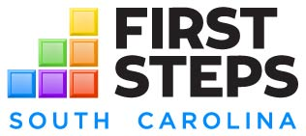

FY20 NEEDS AND RESOURCES ASSESSMENT
Key Informant Interview Guide

Use this guide to conduct interviews with state agency representatives, healthcare and behavioral health providers, community providers, library and school personnel, etc.

Person interviewed:
Organization:
Date of interview:
Geographic area served:
Service(s) provided:
Estimated # of children served 0-5:
Primary school readiness risk factors served by the organization:
Does the organization currently collaborate with First Steps for referrals or other services? Please describe:

- What services do you provide for children 0-5 or their primary caregivers?
- How many clients do you currently serve?
- Are you at capacity? If not, do you have a waiting list?
- What areas of our county do you serve? Are there any areas of the county that are not served, or are under-served? Why?
- Are there any eligibility restrictions on the clients you serve (i.e., income eligibility, age, etc.)?
- What early childhood services do your families need?
- What are potential barriers to your clients accessing early childhood programs?
- How can First Steps assist your organization?

