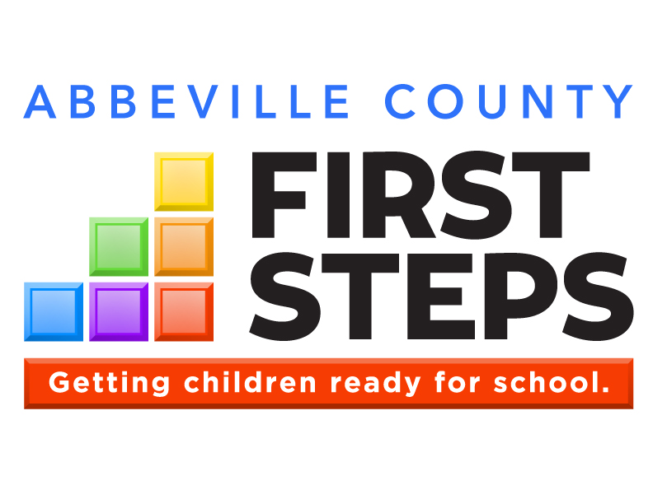
web site or SCFS web page
Address, City, SC Zip ♦ (???)???-???? ♦ email

OUR VISION:

Write the vision statement from your comprehensive plan here.
After you import your new logo for the first time (Insert Picture), right-click on the image, select “Size and Position”, choose the “Text Wrapping” tab and select “In Front of Text” so the logo will cover anything it overlaps. Copy/paste this image to your other pages. If you right-click on the image and select “Change Picture”, all formatting will be correct. Delete this text box.

Annual Report

2017-18
Parents as Teachers
Imagination Library
Countdown to Kindergarten
Child Care Quality Enhancement
Child Care Training
Child Care Scholarships
**Note: Change Photos throughout document.
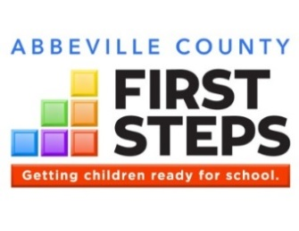

Director/Board Chair Message
This is the title of your message

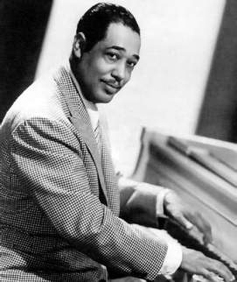
Here is where you describe local examples using collaborations and partnerships to expand services for children and families, as well as dollars leveraged. Here is where you describe local examples using collaborations and partnerships to expand services for children and families, as well as dollars leveraged.
Here is where you describe local examples using collaborations and partnerships to expand services for children and families, as well as dollars leveraged. Here is where you describe local examples using collaborations and partnerships to expand services for children and families, as well as dollars leveraged.
Here is where you describe local examples using collaborations and partnerships to expand services for children and families, as well as dollars leveraged. Here is where you describe local examples using collaborations and partnerships to expand services for children and families, as well as dollars leveraged. Here is where you describe local examples using collaborations and partnerships to expand services for children and families, as well as dollars leveraged.

Add a caption if you want. Also replace Sir Duke with a photo of the letter writer (ED or board chair)
OUR MISSION:

Write the mission statement from your comprehensive plan here.
To create a map image with your county highlighted, double-click on your county (not on the county name) and then select “Shape Fill” from the menu at the top. Then copy and paste the entire map to the annual report.
Delete this text box.
Delete icons you don’t use.
Delete this text box.
Name
Title
Find XYZ First Steps:
County Programs
Parents as Teachers
Child Care Training

State Programs
Early Head Start
First Steps 4k

School
Transition
Early
Education
Quality
Child Care
Early
Intervention
Family
Strengthening

Heathy
Start

www.yourwebsite.org
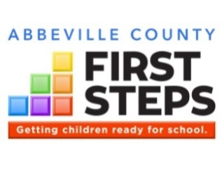

THE NEED

We get children ready.
School readiness depends on the capacity of caregivers to provide children with consistent, nurturing, and responsive relationships in safe, stimulating learning environments, continuously, starting at birth. Unfortunately, these quality early childhood experiences happen for too few children in XYZ County.

How are XYZ County’s  children doing? |  | What early learning programs are available for children in our county? Last year:  1st column:  1st 4 rows: Kids Count: https://datacenter.kidscount.org/ select SC, then county  Readiness: scprofile.com, select county, then select “K5” button  2nd column:  WAIT UNTIL SEPT 21 TO ENTER SCPROFILE.COM DATA  Scprofile.com, select county, select Early Ed icon (2 crayons). Will need to add together school and Head Start #s, and add early intervention #s together.  If a service like Early Head Start or First Steps 4K are not available in your county, enter “not available” instead of zero.  3rd column:  1st 2 rows: Scprofile.com, select county, select ABCQ icon. Row 3: add ABCQ centers and homes together and divide by the total # of centers and homes to get the % in ABCQ.  Row 4: abcquality.org, advanced search for county, add # of providers at B or above. Do not include Head Starts or schools  Row 5: scprofile.com, select county, select Early Ed icon (2 crayons) add all voucher #s together for county  Delete this text box. |  | Where can families access child care in our county?
XXX | are under age 5 | XXX | attended Early Head Start as infants and toddlers | XXX | licensed child care centers
XX% | live in poverty | XXX | attended free preschool or Head Start as 3-year-olds | XXX | licensed group/family homes
XX% | of babies born in 2016 were to moms without a HS diploma | XXX | 4-year-olds attended free full-day public school 4K or Head Start | XX% | participate in the state’s Quality Rating System (ABC Quality)
XX% | select a statistic from Kids Count | XXX | 0-5 year olds received early intervention or special ed. | XX | providers are rated B or higher by
XX% | of last year’s kindergartners demonstrated readiness | XXX | were served by | XX | families received assistance with affording child care last year
Kids Count data provided by: |  | Data provided by: |  | and

THE GOALS
Our partnership’s work, in collaboration with state and local partners, is focused on advancing XYZ County towards these strategic goals in support of the Profile of the Ready Kindergartner, South Carolina’s description of school readiness:
- Goal 1 from Comprehensive Plan
- Goal 2 from Comprehensive Plan
- Goal 3 from Comprehensive Plan
- Goal 4 from Comprehensive Plan, etc.

THE IMPACT
In 2017-18, XYZ County First Steps provided: (edit as needed. All numbers must be derived from your numbers served Matrix spreadsheet)
- # children and # adults with intensive support to equip parents and caregivers with the confidence and competence to be a child’s first and best teacher, and strengthen their family’s health, economic, and overall well-being (List programs this applies to. Ex: Parents as Teachers, Triple P Parenting Program)
- # staff working in # child care providers, Head Start centers and preschool classrooms with training, technical assistance, resources and support, helping them better meet the needs of # children ages 0-5 in their care (List programs)
- financial assistance to help # children 0-5 attend quality child care so their parents can work or attend school (Child Care Scholarships)
- # books to spark the love of reading for # children (List programs)
- a total of # children and # adults were impacted by XYZ County First Steps programs, resources, activities and events.

web site or SCFS web page ♦ email address
NAME, Executive Director ♦ (???)???-???? ♦ NAME, Board Chair
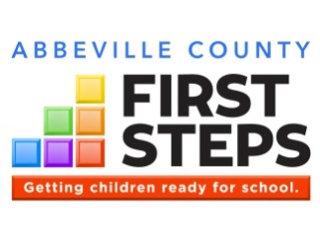
What is the KRA?
In 2017-18, kindergartners across the state were given for the first time South Carolina’s newest assessment of school readiness: the Kindergarten Readiness Assessment, or KRA. The KRA provides a snapshot of students’ abilities at the beginning of the school year, in four domains: Social Foundations, Language and Literacy, Mathematics, and Physical Development and Well-Being. Here are the results locally and for the state:
Address, City, ZIP
Phone
Email Web Address

School Readiness Outcomes

NAME OF DISTRICT (# children)
Domain | Emerging | Approaching | Demonstrating
Social Foundations | ??% | ??% | ??%
Language&Literacy | ??% | ??% | ??%
Mathematics | ??% | ??% | ??%
Physical Dev&WB | ??% | ??% | ??%
OVERALL | ??% | ??% | ??%

NAME OF DISTRICT (# children)
Domain | Emerging | Approaching | Demonstrating
Social Foundations | ??% | ??% | ??%
Language&Literacy | ??% | ??% | ??%
Mathematics | ??% | ??% | ??%
Physical Dev&WB | ??% | ??% | ??%
OVERALL | ??% | ??% | ??%

SOUTH CAROLINA (54,927 children)
Domain | Emerging | Approaching | Demonstrating
Social Foundations | 28% | 27% | 45%
Language&Literacy | 23% | 43% | 34%
Mathematics | 31% | 38% | 31%
Physical Dev&WB | 28% | 24% | 48%
OVERALL | 26% | 38% | 36%

NAME OF DISTRICT (# children)
Domain | Emerging | Approaching | Demonstrating
Social Foundations | ??% | ??% | ??%
Language&Literacy | ??% | ??% | ??%
Mathematics | ??% | ??% | ??%
Physical Dev&WB | ??% | ??% | ??%
OVERALL | ??% | ??% | ??%

NAME OF DISTRICT (# children)
Domain | Emerging | Approaching | Demonstrating
Social Foundations | ??% | ??% | ??%
Language&Literacy | ??% | ??% | ??%
Mathematics | ??% | ??% | ??%
Physical Dev&WB | ??% | ??% | ??%
OVERALL | ??% | ??% | ??%

NAME OF DISTRICT (# children)
Domain | Emerging | Approaching | Demonstrating
Social Foundations | ??% | ??% | ??%
Language&Literacy | ??% | ??% | ??%
Mathematics | ??% | ??% | ??%
Physical Dev&WB | ??% | ??% | ??%
OVERALL | ??% | ??% | ??%

Enter data from EOC Report:
https://www.eoc.sc.gov/Reports%20%20Publications/KRA%20Report.June%202018/KRA%20Report%202018.06152018.pdf
District results start on p. 15. You will need to add up # children tested (use Overall row).
Highlight the #’s in yellow where the district exceeds the state average in % demonstrating readiness. A couple of cells are highlighted to demonstrate.
Delete school district tables you don’t need. Additional boxes of KRA definitions are provided to fill up space. You may also want to add photos, etc. that relate to your partnership’s readiness message, if space permits.
Delete this text box.

Demonstrating Readiness: student demonstrates foundational skills and behaviors that prepare him/her for instruction based on kindergarten standards.
Approaching Readiness: student demonstrates some foundational skills and behaviors that prepare him/her for instruction based on kindergarten standards
Emerging Readiness: student demonstrates limited foundational skills and behaviors that prepare him/her for instruction based on kindergarten standards

- Language and Literacy: reading, writing, speaking, and listening
- Mathematics: counting, comparison, and sorting
- Physical Well-Being & Motor Development: dexterity, muscular coordination, and balance
- Social Foundations: following rules, asking for help, task persistence and other skills necessary to function within the kindergarten classroom

What is XYZ County First Steps doing to improve KRA results (or something similar):
Write in this section your partnership’s position on what the county’s results for the first year of KRA mean, and what your partnership and local partners (think convener!) are doing to improve these results. Examples include: additional training for staff or teachers on a certain area of development (like social and emotional), expanding a program or starting a new program, increasing outreach to certain underserved areas of your county, etc.
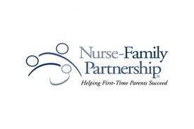
Helping vulnerable first-time mothers empowers them to achieve a better life
for themselves and their children.

Nurse-Family Partnership

Program Description
Evidence of Effectiveness:
Nurse-Family Partnership meets the First Steps legislation’s definition of an evidence-based program.

NFP by the Numbers, 2017-18
Children Served | Matrix C36
Number of Home Visits | Matrix F36

This year, our NFP program (contact jkilburn@scfirststeps.org for assistance, if needed):
- IF AVAILABLE, INCLUDE STATISTICS ON CLIENT SATISFACTION (satisfaction survey, training evals, etc.)
- Achieved ??? results for healthy pregnancy, healthy birth outcomes
- Achieved ???? results for improved parent behaviors, like quitting smoking, parenting skills, etc.
- Graduated ??? families (if applicable)

Here’s a great quote from a client!
Client name

Nurse-Family Partnership (NFP) helps transform the lives of vulnerable first-time mothers and their babies. Through ongoing home visits from registered nurses, low-income, first-time moms receive the care and support they need to have a healthy pregnancy, provide responsible and competent care for their children, and become more economically self-sufficient. From pregnancy until the child turns two years old, Nurse-Family Partnership Nurse Home Visitors form a much-needed, trusting relationship with the first-time moms, instilling confidence and empowering them to achieve a better life for their children – and themselves.
In XYZ County, Nurse-Family Partnership is implemented through XYZ Organization.

XYZ First Steps serves families in greatest need. Among our NFP families:
XX% | … live in poverty
XX% | … graduate from high school
XX% | … had developmental delays

Thank you to our NFP partners!
U.S. Department of Education
XYZ County School District Family Literacy
ABC Child Care
Fairview Mental Health Services

Early Identification and Referral
Identifying and referring children with possible developmental delays can help assure school readiness.

Program Description
Here’s a great quote from a client!
Client name
Also include any measures of client satisfaction HERE or in the results below

First Steps’ Early Identification and Referral (EI&R) programs serve families with young children with suspected delays in development and coordinates public awareness for BabyNet services, acting as a local portal to connect families to community-based services they may need or desire to ensure the school readiness of their children
EI&R services include:
- Screenings (developmental, vision, hearing) for children ages birth to 5 years with suspected delays in development
- Referrals, based up the screening results, to appropriate community resources. This could include the local BabyNet System Point of Entry Office, the local school district, and/or support services such as speech therapy, physical therapy, and programs in libraries and other community resources.
- Parent information including strategies to monitor growth and development.
Our EI&R program:
- Provides early detection of developmental delays and health issues
- Promotes services and activities that promote child development
- Increases children’s school readiness and school success

XYZ First Steps serves families in greatest need. Among our EI&R families:
X% | … live in poverty
% | … didn’t graduate high school
25% | … were teen parents

The risk factor box underneath is a Table. To add or delete lines, you must Insert or Delete Rows by right-clicking on the appropriate line. This applies to all pages that include a risk factor box.
Use data from the Risk Factor Report to find the most compelling statistics for your program.
Delete this text box.
Evidence of Effectiveness:
Early Identification and Referral meets the First Steps legislation’s definition of an evidence-based program.
Use text boxes to caption your photos as often as possible. Many readers will focus on these more than the report text.

EI&R by the Numbers 2017-18
Children Served | Matrix C92
Materials Distributed | Matrix F92
Children Referred to BabyNet, Local School, or Other Services | FSDC EI&R outputs: #13 + #16

This year, our Early Identification and Referral program:
- Screened xxxx number of children using Ages and Stages Questionnaire
- Referred xxxxx number of families to community resources after screening indicated need

Thank you to our EI&R partners!
XYZ County School District Family Literacy
ABC Child Care
Fairview Mental Health Services

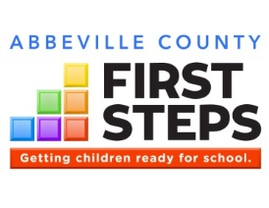

Here’s a great quote from a client!
Client name
Also include any measures of client satisfaction HERE or in the results below

Parents as Teachers

Program Description
Parents play a critical role in their child’s development.
The risk factor box underneath is a Table. To add or delete lines, you must Insert or Delete Rows by right-clicking on the appropriate line. This applies to all pages that include a risk factor box.
Use data from the Risk Factor Report to find the most compelling statistics for your program.
Delete this text box.
Parents as Teachers (PAT) is an evidence-based home visiting program designed to build strong communities, thriving families and children who are healthy, safe and ready to succeed. PAT services include:
- Personal Visits at least twice monthly
- Monthly Group Connections with other PAT families
- Screenings and Assessments to identify developmental concerns
- Connections to Outside Resources that families may need to succeed
XYZ First Steps serves families in greatest need. Among our PAT families:
100% | … live in poverty
50% | … didn’t graduate from high school
25% | … were teen parents

PAT by the Numbers 2017-18
Families Served | Matrix D28
Children Served | Matrix C28
Total Home Visits | Matrix F28
Hours Spent Serving Families | Matrix: G28+I28
Average gain, Keys to Interactive Parenting Scale (pre-to-post): | KIPS/ACIRI Detail Report | KIPS/ACIRI Detail Report

Use text boxes to caption your photos as often as possible. Many readers will focus on these more than the report text.

This year, our Parents as Teachers program:
- Averaged XX home visits per family (Parenting Home Visit Intensity Report, Avg. Number of Visits)
- Identified and addressed XX potential developmental delays (ASQ Report), and made ## connections for families to services such as ??????? (Connections Detail Report)
- Improved parenting practices write something about your pre-to-post changes KIPS, LSP, or other evidence
- Improved literacy skills write something about pre-to-post changes in ACIRI, activities from PAT lessons, # of books distributed (Matrix C20, Cases Visit Summary & PTS Report), or other evidence

Evidence of Effectiveness:
Parents as Teachers meets the
First Steps legislation’s definition
of an evidence-based program.
XYZ County School District Family Literacy
ABC Child Care
Fairview Mental Health Services

Thank you to our PAT partners!
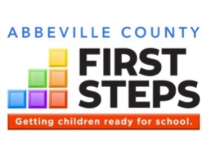

Family Literacy
Parents are their child’s first and best teachers.

Program Description
Evidence of Effectiveness:
The Family Literacy components of name of parenting program and early childhood education meet the
First Steps legislation’s definition
of an evidence-based program.

Thank you to our Family Literacy partners!
Use text boxes to caption your photos as often as possible. Many readers will focus on these more than the report text.
Also include any measures of client satisfaction HERE or in the results below
The risk factor box underneath is a Table. To add or delete lines, you must Insert or Delete Rows by right-clicking on the appropriate line. This applies to all pages that include a risk factor box.
Use data from the Risk Factor Report and program records to find the most compelling statistics for your program.
Delete this text box.
Family literacy programs offer an integrated and family-friendly approach, helping both parents and children to improve their literacy skills. Family literacy services integrate all of the following:
- Adult Education
- Child Education
- Parent Education
- Interactive Parent/Child Activities
Our family literacy program:
- Helps parents of young children increase their education levels
- Provides English language instruction for parents (delete if not the case)
- Teaches parents how to support their child’s literacy and overall development
- Provides quality early learning experiences for children 0-5 while their parents attend adult education
XYZ First Steps serves families in greatest need. Among our family literacy program families:
X% | … live in poverty
X% | … didn’t graduate high school
X% | … enrolled in our program with less than an eighth grade education

This year, our Family Literacy program:
- Increased the education levels of participating parents by an average of ? grade levels in ???? (pre to post TABE scores in reading and/or math)
- Increased the vocabulary skills of participating children by ??? (pre to post PPVT scores)
- Other results such as: participants enrolling in higher education or getting a job; ESL parents achieving gains in their English language skills (pre to post BEST);

Family Literacy by the Numbers 2017-18
Adults Served | Matrix E58/59
Children Served | Matrix C58/59
Adult Education Hours Offered | Matrix I58/59
Early Childhood Education Hours Offered | Matrix K58/59
Parenting Education Hours Offered | Matrix M58/59
Number of adults that achieved their HS diploma or GED | FSDC, Case Info screen

U.S. Department of Education
XYZ County School District Family Literacy
ABC Child Care
Fairview Mental Health Services

Imagination Library
Children’s reading scores improve dramatically when parents are involved
in helping them learn to read.

Sponsor a child today for just $25 a year!
This year, our Imagination Library program:
- Provided one book per month to (Matrix C63) children who were referred from LIST
REFERRAL SOURCES
- Other results such as: results from client surveys; connections with other programs such as
PAT, Head Start, etc.
- Received donations from ?? community members and organizations in support of children’s literacy (if applicable)
- IF AVAILABLE, INCLUDE STATISTICS ON CLIENT SATISFACTION (satisfaction survey, training evals, etc.)

Thank you to our Imagination Library partners!
Evidence of Effectiveness:
Imagination Library meets the
First Steps legislation’s definition
of an evidence-based program.
Use text boxes to caption your photos as often as possible. Many readers will focus on these more than the report text.

Imagination Library by the Numbers, 2017-18
Children Served | Matrix C63
Books Given to Children 0-5 | Matrix C17

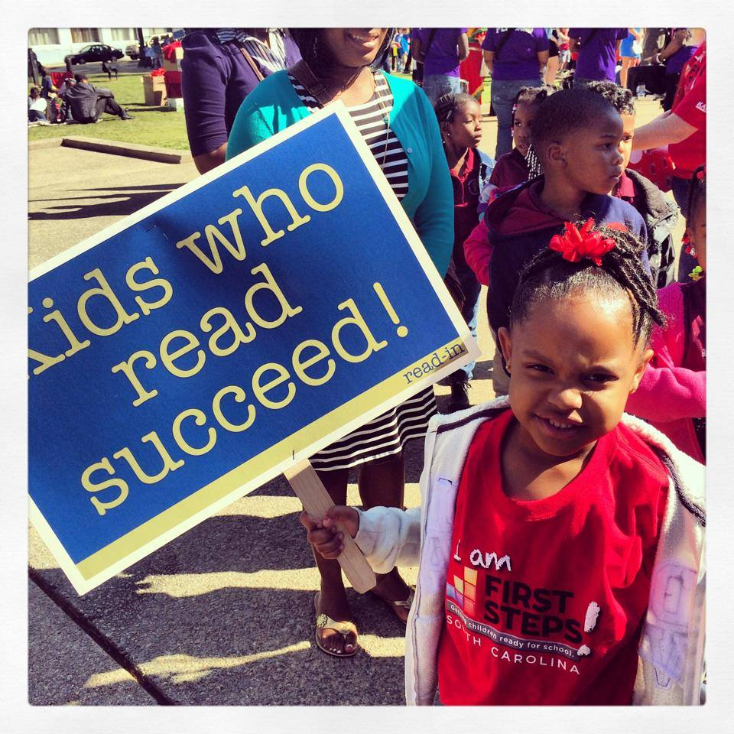
Dollywood Foundation
XYZ County School District Family Literacy
WalMart Store #1001, XYZ
Dollar General Literacy Foundation

Program Description
According to the Center on the Developing Child at Harvard University, the peak period for brain development related to language is around nine months of age. One of the easiest and most effective ways to build this capacity in young children’s brains is to read to them.
XYZ First Steps is the local sponsor of Dolly Parton Imagination Library, which provides free, age-appropriate books to children age birth to 5 years. Operated by the Dollywood Foundation, Imagination Library is currently in more than 1,600 communities internationally and mails books to about 700,000 children each month.
Children who register with XYZ First Steps receive one book per month by mail through the month of their fifth birthday. Each book is carefully selected by a committee of educational specialists.
In order to thrive, children need nurturing, responsive relationships and a
supportive learning environment, both within and outside the home.

Child Care Quality Enhancement

QE by the Numbers, 2017-18
Child Care Providers Served | Matrix D72
Number of TA Visits Provided | Matrix F72
Number of Children 0-5 Enrolled in Provider Classrooms | Matrix C72

Program Description
This year, our Quality Enhancement program:
- IF AVAILABLE, INCLUDE STATISTICS ON CLIENT SATISFACTION (satisfaction survey, training evals, etc.)
- Improved quality, on average, by X.X based on pre/post Environment Rating Scale assessments. (Child Care Intensity Summary Report, Column “ERS Change, Pre to Post”)
- Congratulate any providers that advanced in ABC Quality
- Provided XX hours of technical assistance to child care providers (Matrix G72), contributing to the professional growth of XX child care teachers and directors (Matrix E72)
- Provided $????? in materials grants to participating child care providers (if applicable)
- Funded scholarships for XX children within participating child care providers (if applicable)

Evidence of Effectiveness:
Child Care Quality Enhancement
meets the First Steps legislation’s definition of an evidence-based program.

Thank you to our Quality Enhancement partners!
The QE pre/post box underneath is a Table. To add or delete lines, you must Insert or Delete Rows by right-clicking on the appropriate line.
Delete this text box.
Congratulations to our QE participants for 2017-18!
Child Care Provider | Pre/Post Improvement
Name of Provider, toddler room | From 2.6 to 3.5
Name of Provider, infant room | From 3.0 to 3.3
Name of Provider, 2-yr-old room | From 1.9 to 3.2
Name of Provider, 3-yr-old room | From 2.0 to 2.4
Name of Provider, infant room | From 3.2 to 3.6

The quality of care they received by young children is crucial to their healthy development and school readiness. Child care providers strive to provide high quality care, but may lack the resources that are commonly available to publicly-funded early childhood programs, such as educational materials, on-site professional development, and other support.
First Steps’ Child Care Quality Enhancement (QE) is intended to produce measurable improvements in the quality of care provided to young children. Participating child care providers must serve a high percentage of at-risk children, and are selected through a competitive process that requires a strong level of commitment to the QE process.
Program Components
- On-site Technical Assistance (TA) at least twice monthly
- Equipment and materials funding
- Integration with locally available training, provided by First Steps and other partners
- Workforce Development
- Coordination with community partners
- Pre/post assessments of the classroom environment and teacher-child interaction, using nationally-recognized observational tools for infant/toddler and preschool settings (ITERS,ECERS,FCCERS)

U.S. Department of Education
XYZ County School District Family Literacy
ABC Child Care
Fairview Mental Health Services

Those who care for young children need high-quality, accessible, and affordable professional development.

Child Care Training

This year, our Training program provided:
- XX early childhood staff with high quality training (Matrix E76), impacting XX providers (Matrix D76) and XXX children (Matrix C76)
- XX hours of certified training (Matrix H76) and XX hours of registered training (Matrix I76) for staff to meet annual re-certification requirements
- XX follow-up visits (Matrix J76) with training participants to help put training into practice

Evidence of Effectiveness:
Child Care Training and Professional Development meets the First Steps legislation’s definition of an
evidence-based program.
Use text boxes to caption your photos as often as possible. Many readers will focus on these more than the report text.
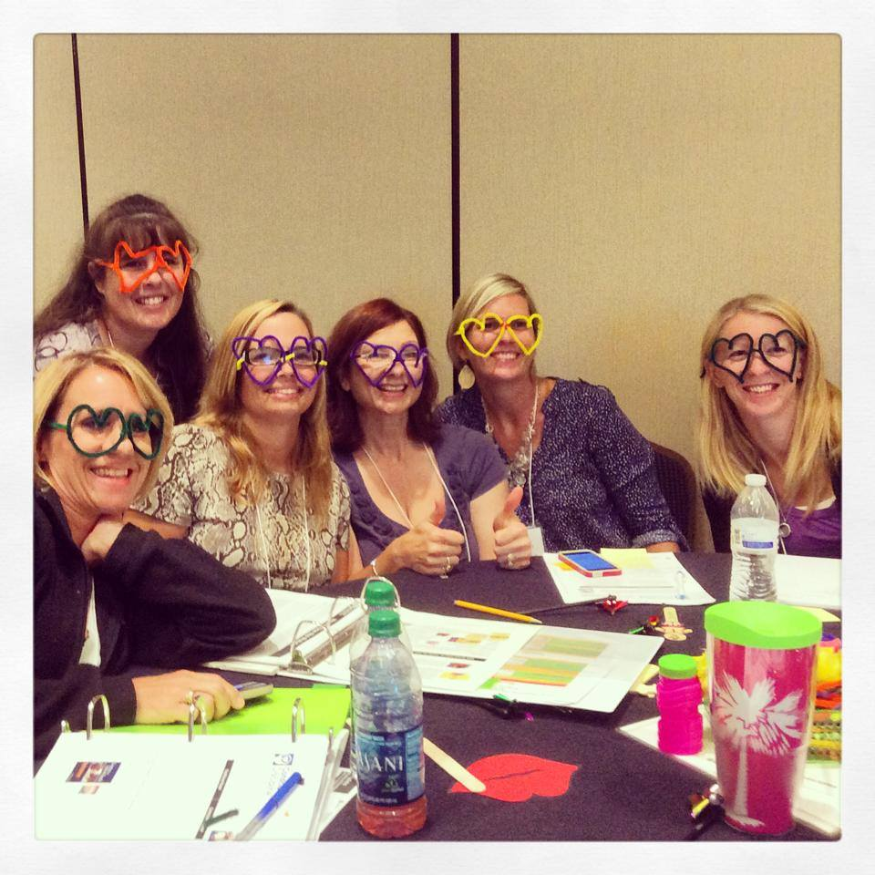

Training by the Numbers, 2017-18
Total Training Attendance | Matrix F76
Child Care Teachers and Directors Served | Matrix E76
Number of Training Sessions Offered | Matrix G76

Training Sponsored by
XYZ First Steps, 2017-18
Topic: Sessions:
SC Infant/Toddler Guidelines Modules 1,2, and 5
Preventing Child Abuse and Neglect:
Parent-Provider Partnerships Modules 1 and 3
Blood-Borne Pathogens One Session
Early Literacy in the Child Care
Classroom Three Sessions

High-quality child care hinges on high-quality professional development that meets the needs of the local child care workforce.
First Steps-sponsored training is certified through the SC Center for Child Care Career Development and includes topics in the areas of nutrition, health and safety, curriculum, child guidance, professional development and program administration. Best practices in training include not only the training itself, but follow-up in the classroom.

Program Description

Thank you to our Training partners!
U.S. Department of Education
XYZ County School District Family Literacy
ABC Child Care
Fairview Mental Health Services

Here’s a great quote from a client!
Client name
Also include any measures of client satisfaction HERE or in the results below

Child Care Scholarships
Too many families in XYZ County cannot afford quality care for their children.

Program Description
Use text boxes to caption your photos as often as possible. Many readers will focus on these more than the report text.
Evidence of Effectiveness:
Our partnership’s Child Care Scholarship
sstrategy is considered evidence-based
because it is connected to the following
evidence- based programs:
program name(s). OR CHANGE LANGUAGE
TO EVIDENCE-INFORMED AS APPLICABLE
The risk factor box underneath is a Table. To add or delete lines, you must Insert or Delete Rows by right-clicking on the appropriate line. This applies to all pages that include a risk factor box.
Use data from the Risk Factor Report to find the most compelling statistics for your program.
Delete this text box.
Here’s a great quote from a client or child care provider!
Client name
Also include any measures of client satisfaction HERE or in the results below

Scholarships by the Numbers, 2017-18
Children Served | Matrix C85
Providers Served | Matrix F85

This year, our Scholarship program:
- Provided XX children (Matrix C85) with scholarship assistance so their parents could work or attend school
- Identified and addressed XX potential developmental delays among scholarship children (ASQ Report)
- Made ## connections for families to services such as ??????? (Connections Detail Report and joint services like PAT)
- Supported XX small businesses (Matrix F85) in XYZ County by subsidizing child care tuition for families who would not otherwise be able to afford quality care
- Provided XX hours (Matrix H85) of training for scholarship parents in topics such as ???????

Access to quality child care is essential for children while away from their primary caregivers. Yet, of those families income-eligible for child care assistance in South Carolina, only a small fraction receive it due to lack of funds. In the absence of nurturing and consistently available family, friends or neighbors, parents are faced with few - or no – affordable care options.
XYZ First Steps serves families in greatest need. Among our scholarship families:
XX% | … live in poverty
XX% | … didn’t graduate from high school
XX% | … were teen parents
XX% | … had developmental delays

In addition to regular monitoring of child care providers that receive First Steps scholarships, First Steps conducts at least one developmental screening each year with scholarship children and connects families to needed services within the community.
If your partnership integrates scholarships with another program, such as Parents as Teachers, Family Literacy, Imagination Library etc., mention that here.

Thank you to our Scholarship partners!
U.S. Department of Education
XYZ County School District Family Literacy
ABC Child Care
Fairview Mental Health Services

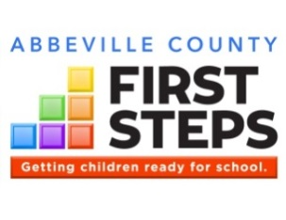
Children involved in high-quality preschool are more likely to have better academic outcomes.

Early Education
Here is the place where you summarize your program. Connect your program’s purpose to the “WHY” statement above.
Describe the desired outcomes of your program.
Describe the components of your program, using subheadings, bullets and/or numbering to organize it for the reader. For example:
- Component 1
- Component 2
- Component 3
If you have risk factor data for this strategy, copy/paste the “risk factor box” from other pages and insert it here.

Program Description
This year, our Early Education program:
- Made it possible for XX children to attend quality preschool (Matrix C66-69)
- Program results such as: child outcomes, parent involvement, nutrition/health, teacher training, etc. if applicable
- Program results such as: child outcomes, parent involvement, nutrition/health, teacher training, etc. if applicable

Evidence of Effectiveness:
Our partnership’s Early Education program meets the First Steps legislation’s definition
of an evidence-based program.

Thank you to our PROGRAM NAME partners!
Use text boxes to caption your photos as often as possible. Many readers will focus on these more than the report text.

Early Education by the Numbers, 2017-18
Children Served | Matrix C66-69
Providers Served | Matrix D73

Here’s a great quote from a client!
Client name
Also include any measures of client satisfaction HERE or in the results below

XYZ County School District
ABC Child Care
Fairview Mental Health Services

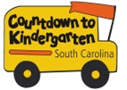

*CTK by the Numbers, Summer 2017
Children Served | Matrix C88
Families Served | Matrix D88
Home/School Visits | Matrix G88

*CTK program data is for June-August 2017, whereas CTK fiscal data includes expenditures from July 1, 2017 through June 30, 2018.
Countdown to Kindergarten (CTK) is a summer home visitation model connecting rising kindergartners and their families with their future teachers. The program is designed:
- to forge strong and lasting home-school relationships,
- to acquaint children and families with the state and classroom expectations to increase the likelihood of school success,
- to increase parent involvement in the early grades (particularly in hard-to-reach communities), when children’s learning is foundational for life success; and
- to increase public awareness of the importance of school readiness and provide ways for parents and communities to impact children’s early school success.

Countdown to Kindergarten integrates all of the following:
Home Visitation. Teachers make six visits over the summer to the homes of participating students and families. Children and families are introduced to actual materials used in kindergarten and are given a Kindergarten Transition Toolkit to keep.
Learning Celebration. The last visit is a “field trip” to the school where the child will attend class in the fall.
Public Awareness. Throughout the summer, First Steps releases tips to media to help parents and caregivers get children ready for kindergarten.

Unless you have a good reason, your CTK results and data should be from Summer 2017 – the same as reported in the data matrix - and survey data from the 2017-18 school year.
However, if you just started CTK in Summer 2018, or made some significant change like increasing the numbers served in Summer 2018, you can report on Summer 2018 instead of, or in addition to, Summer 2017 on this page. Make sure you clearly label your data!
Delete this text box.

Here’s a great quote from a CTK client!
Client name

Countdown to Kindergarten
Bringing parents and teachers together as partners sets the foundation for success in school.
Evidence of Effectiveness:
Our partnership’s Countdown to
Kindergarten program meets the First Steps legislation’s definition
of an evidence-informed program.

This year, our Countdown to Kindergarten program:
- Include satisfaction results from parent surveys.
- Increased the amount of time parents spent reading to children by XX%
- According to kindergarten teachers, XX% of CTK children performed as well as, or better than, their fellow students in LIST AREAS FROM THE CTK TEACHER SURVEY during the 2017-18 school year.
- According to kindergarten teachers, XX% of CTK parents were more involved than other parents in their child’s education in the areas of LIST AREAS FROM THE CTK TEACHER SURVEY.

Like us on Facebook!
Countdown to Kindergarten-South Carolina

Program Description
The risk factor box underneath is a Table. To add or delete lines, you must Insert or Delete Rows by right-clicking on the appropriate line. This applies to all pages that include a risk factor box.
Use data from the Risk Factor Report to find the most compelling statistics for your program.
Delete this text box.
XYZ County School District
Kaplan Early Learning Company
EdVenture Children’s Museum
WACH Fox 57

Thank you to our CTK partners!
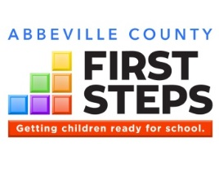

Financial Impact
Change the county name. Delete this text box.

Right click on this pie chart and select “Edit Data” from the toolbar above, or right-click on the pie chart and select “Edit Data”. Enter numbers from the Ethority reports provided. Delete this text box.

Total 2017-18 Expenditures: $305,000
State Funds Leveraged in 2017-18*: 53%
*Percentage of state dollars matched by additional federal, private, and/or in-kind funds

Unaudited numbers for the period July 1, 2017 through June 30, 2018
Double click on this chart to open the Excel spreadsheet and enter numbers from the Ethority reports provided by Annie Cherry.
DO NOT ENTER UNOFFICIAL FY18 EXPENDITURES OR MATCH %: WAIT UNTIL OFFICIAL YEAR END REPORTS ARE EMAILED TO YOU.
Delete this text box.
Since inception, XYZ County First Steps has leveraged $X,XXX,XXX from sources outside of state government. That’s XX cents for every state dollar.

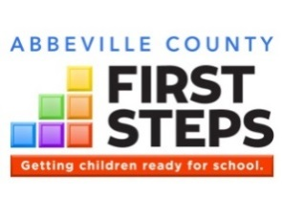
Through partnerships and collaborations, as well as financial support from grants and contributions, XYZ First Steps leverages state dollars to enhance and expand services to children and families.

In-Kind Support
XYZ County School District
ABC Child Care
Fairview Mental Health Services

Funding Support
State of South Carolina: $200,000
(through South Carolina First Steps)
U.S. Department of Education: $50,000
XYZ County Council: $5,000
Dollar General Literacy Foundation: $10,000
Wal-Mart Store #1001, XYZ: $10,000

Support XYZ First Steps today through a tax-deductible donation, or volunteer!

Thank you supporters!
You can insert a photo of donated items or donors if you like. Delete this text box.
How your support helps children in XYZ County:
- $25 provides a young child a book per month for one year!
- $XXX feeds dinner to low-income families attending a parenting workshop
- $XXX helps a low-income family afford quality child care for one month
- $XXX etc. etc.
HOW TO GIVE: include here instructions on how to submit contributions to your partnership

Use text boxes to caption your photos as often as possible. Many readers will focus on these more than the report text.

You can provide info here to donors about how much money it costs to provide a specific service/resource for how many children. Delete this text box.
Use this text box to advertise any community events you have planned for the year, such as your annual meeting, and especially any fundraisers.
If your partnership is going to participate in any giving program like Midlands Gives, add that info here.

Save the Date!
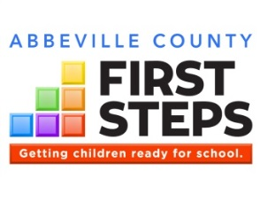
Make a Title for your Success Story
Subtitle/Name of Strategy or Partner
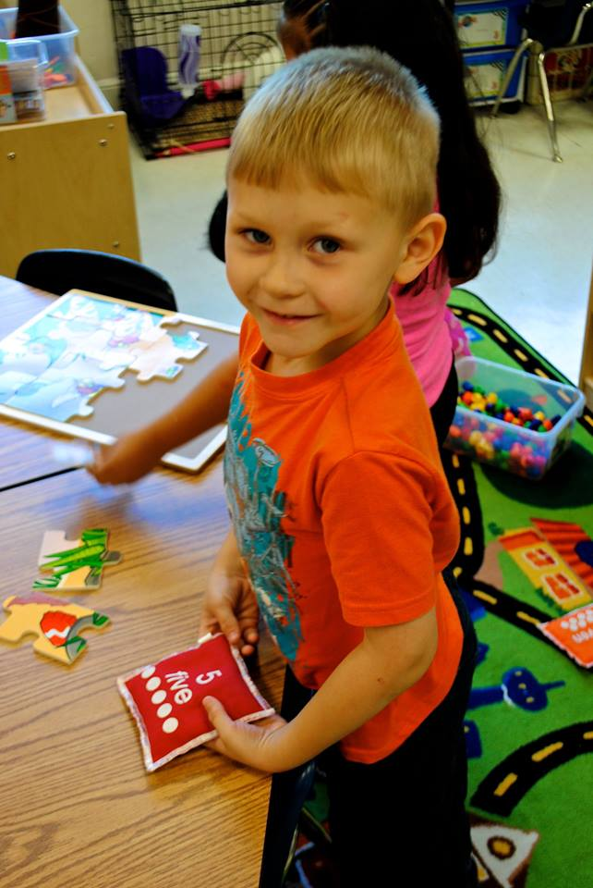
Here is where you write a success story. It can be about whatever you want: a child or family, program, training series, child care center, board member, collaboration, serving as a local portal, whatever. If you have a photo or image you can insert it in place of the photo or you can delete the image.

Community Impact
This is a subheading if you want to use one
Here is where you write a success story. It can be about whatever you want: a child or family, program, training series, child care center, board member, collaboration, serving as a local portal whatever. If you have a photo or image you can insert it in place of the photo or you can delete the image.
Make a Title for your Success Story
Subtitle/Name of Strategy or Partner
Here is where you write a success story. It can be about whatever you want: a child or family, program, training series, child care center, board member, collaboration, serving as a local portal, whatever. If you have a photo or image you can insert it in place of the photo or you can delete the image.
Use text boxes to caption your photos as often as possible. Many readers will focus on these more than the report text.
This is a subheading if you want to use one
Here is where you write a success story. It can be about whatever you want: a child or family, program, training series, child care center, board member, collaboration, serving as a local portal, whatever. If you have a photo or image you can insert it in place of the photo or you can delete the image.
Support XYZ First Steps today through a tax-deductible donation, or volunteer.
Use text boxes to caption your photos as often as possible. Many readers will focus on these more than the report text.
Make a Title for your Success Story about your Board or being a Community Convener
Subtitle/Name of Strategy or Partner

First Steps Partnership Board
Here is where you write a success story about your board or a collaboration involving your board. Here is where you write a success story about your board or a collaboration involving your board. Here is where you write a success story about your board or a collaboration involving your board. Here is where you write a success story about your board or a collaboration involving your board. Here is where you write a success story about your board or a collaboration involving your board. Here is where you write a success story about your board or a collaboration involving your board.
This is a subheading if you want to use one
Here is where you write a success story about your board or a collaboration involving your board. Here is where you write a success story about your board or a collaboration involving your board. Here is where you write a success story about your board or a collaboration involving your board.
Name | Position | Board Category
Betty Gardiner, Chair | Early Childhood Coordinator, Lexington/Richland 5 | School District Representative
Debbie Robertson, Vice Chair | Director of Child Care Services, Lexington County DSS | DSS Representative
Mary Anne Mathews | President, ABC Company | Parent of a Young Child

XYZ County First Steps Partnership Board, 2017-18

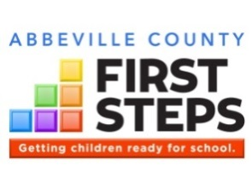
At the state level and in every county, First Steps leverages state funding with other public and private resources to help South Carolina’s children enter kindergarten healthy and ready to succeed. First Steps programs and services support families as their child’s first and most important teacher and are customized to meet the unique needs of local communities, grounded in strong evidence, fueled by stakeholder collaboration, and accountable for results.

What is First Steps?

First Steps Goals
(1) provide parents with access to the support they might seek and want to strengthen their families and to promote the optimal development of their preschool children;
(2) increase comprehensive services so children have reduced risk for major physical, developmental, and learning problems;
(3) promote high-quality preschool programs that provide a healthy environment that will promote normal growth and development;
(4) provide services so all children receive the protection, nutrition, and health care needed to thrive in the early years of life so they arrive at school ready to succeed; and
(5) mobilize communities to focus efforts on providing enhanced services to support families and their young children so as to enable every child to reach school healthy and ready to succeed.
South Carolina Code of Laws, Section 59-152-30

Heathy
Start

Family
Strengthening

Early
Intervention
Quality
Child Care
Early
Education
School
Transition
First Steps Building Blocks of Quality Early Childhood Programs and Services
From Greenville to Charleston, Abbeville to York, First Steps local partnerships serve as …
Local portals connecting preschool children and families to services
Conveners of community stakeholders to address the needs of young children and their families
Champions of the importance of school readiness to our children’s future.

for South Carolina and to learn about First Steps 4K programs in your area:
scfirststeps.org
for XYZ County First Steps:
your web site or SCFS county page

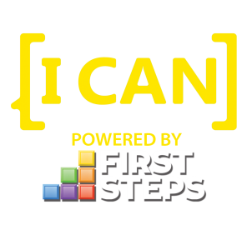
[I CAN] is First Steps’ public awareness campaign for school readiness, in support of the state’s Profile of the Ready Kindergartener. Includes resources for parents, providers and communities to learn what they can do to support school readiness.
Visit: ican.sc
Like us on Facebook: icansc

