Countdown to Kindergarten is a First Steps to School Readiness program to help children get ready for school. As your family’s Countdown teacher, I will meet with you and your child five times to teach and engage in activities that will help prepare your child for kindergarten. On the last visit, we will meet at school so you and your child can see the child’s new kindergarten classroom. There will be art materials, educational toys, and/or a book provided for each visit/lessons. The lessons for each visit and the date and time we will meet are:
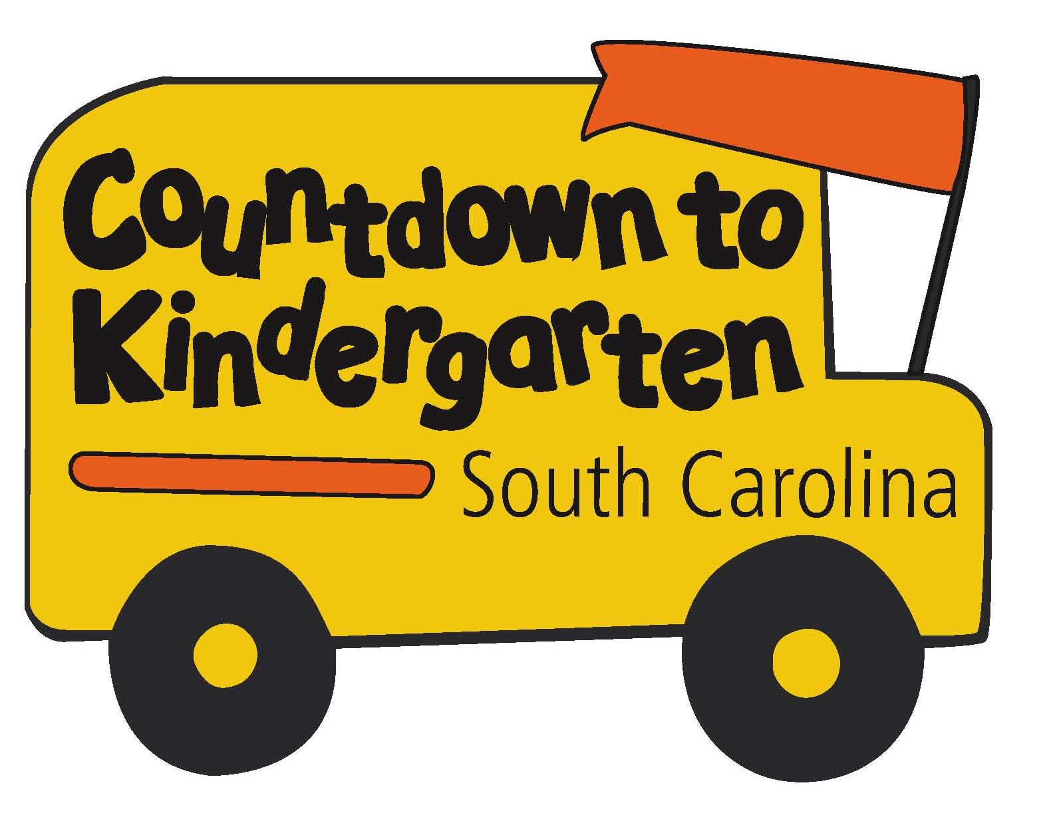 | Countdown to Kindergarten  Family Commitment Form

Week 1-Getting to Know You
Date/Time of Visit 1: _______________________________________________________________

Week 2 – English Language Arts and Literacy
Date/Time of Visit 2: _______________________________________________________________

Week 3 - Math
Date/Time of Visit 3: _______________________________________________________________

Week 4 - Science
Date/Time of Visit 4: _______________________________________________________________

Week 5 - Social Studies
Date/Time of Visit 5: _______________________________________________________________

Week 6 - Visit to the School and Student’s Classroom
Date/Time of Visit 6: _______________________________________________________________

By signing this form, I agree that my child and I will participate in all six visits that I schedule with the Countdown to Kindergarten teacher. If I am unable to keep a scheduled visit, I will contact the teacher and reschedule for another time. I agree to be present at the five home visits and to attend the final visit at my child’s classroom.

______________________________________________ __________________________
Parent/Guardian Name Date

__________________________________________________ ____________________________
Teacher Name Date

_________________________________________________
Teacher Contact Information

